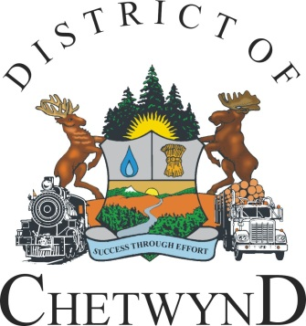
District of Chetwynd

Box 357
Chetwynd, BC
Canada V0C 1J0

tel: (250) 401-4100
fax: (250) 401-4101
email: d-chet@gochetwynd.com

Effective September 1, 2020:

Bulk Sewer Dump Station rates will increase from $6.10 per cubic meter to $12.00 per cubic meter in accordance with District of Chetwynd Sewer Fees and Charges Amendment Bylaw No. 1121, 2020.

Please contact the District main office at 250-401-4100 with any questions.

