
Project Summary
Request for Quote Blending Winter Salted Sand

June 26, 2026
Supply of Coarse Winter Salt, blending with winter sand, and stockpiling by Contractor-supplied conveyor belt, of approximately 800 cubic yards of coarse winter salted sand. Salt to be supplied by the Contractor.

Key Dates

Date of Issue | June 26, 2026
Deadline for Submitting Questions | July 10, 2026
RFQ Closing Date | July 16, 2026 at 2:00:00 pm local time
Anticipated Award Date | July 23, 2026
Product To Be Delivered By | August 31, 2026

Every attempt will be made to meet all the dates listed above; however, the Owner reserves the right to modify any or all dates at its sole discretion.

RFQ documents are available for download at:

- District of Chetwynd website at https://www.gochetwynd.com/

Contents
1. Instructions to Bidders 3
1.1 Definitions 3
1.2 Submission of Bids 3
1.3 Acceptability of Bid Submission 3
1.4 Contract Award 4
1.5 Extras 4
1.6 Default 4
1.7 Liability 4
1.8 Bid Withdrawal 4
1.9 Amendment of Bid Submissions 4
1.10 Payment 4
1.11 FOIPPA 5
2. Scope of Work and Specifications 6
2.1 Sand Quantity and Specifications 6
2.2 Delivery Requirements 7
2.3 Rejection of Defective Products 7
2.4 Samples and Testing 7
3. RFQ Forms 8
3.1 Form 1 – Company Details 9
3.2 Form 2 – Bid Sheet 10

Instructions to Bidders

Definitions
For the purposes of this Request for Quotes:

Bidder means the individual or company that submits, or intends to submit, a Bid Submission for consideration.

Bid Submission means a bid submitted in response to the RFQ

Closing Time means the day and time specified in this document by which the Bid Submission must be received by the Owner.

Contract means the written form of agreement between the Owner and the Contractor.

Contractor means the successful Bidder to this RFQ process who enters into a written Contract with the Owner.

Owner means the District of Chetwynd.

RFQ means Request for Quote.

Submission of Bids

Bid Submissions must be received by 2:00:00 pm local time on July 16, 2026 at the District Office located at 5400 Hospital Road, Chetwynd, BC V0C 1J0 or electronically by emailing to sweightman@gochetwynd.com

Bid Submissions delivered in hard copy must be in sealed envelopes marked clearly with the following: “Sealed Bid, Winter Sand RFQ, Attn: Director of Engineering & Public Works”

Bid Submissions delivered by email must contain the following in the email subject line: “Sealed Bid, Winter Sand RFQ, Attn: Director of Engineering & Public Works”

Bid Submissions received after the Closing Time may not be accepted.

Questions related to this RFQ should be directed in writing by email to sweightman@gochetwynd.com

The deadline for submitting questions related to this RFQ is July 10, 2026.

Acceptability of Bid Submission

The Owner reserves the right to:
- reject any or all Bid Submissions, or any part thereof;
- accept the Bid Submission that is in the best interest of the Owner; the lowest Bid Submission shall not necessarily be accepted;
- waive any informality in the Bid Submissions.

By providing a Bid Submission, the Bidder is expressly accepting all terms and conditions referenced in this RFQ.

Bid Submissions that are unsigned, incomplete, illegible, unbalanced, obscure, or contain irregularities may be rejected as informal.

Award of this Contract is subject to the approved budget.

Contract Award
A Purchase Order will be issued upon award of the Contract. The PO number shall be referenced on all invoices.

Extras
Except as otherwise provided in the Contract, no payment for extras shall be made unless such extras have been authorized in writing by the Owner.

Default
The Owner may, subject to the provisions of this section, by written notice of default to the Contractor, terminate the whole or any part of this Contract if the Contractor fails to make delivery of the supplies, or to perform the services within the time specified herein or any extension thereof.

Liability
The Contractor shall ensure that the Owner, its officers and employees, are saved harmless from any liability whatsoever arising out of the Contractor's performance or non-performance of the terms of this RFQ, including the performance by any sub-contractor.

Bid Withdrawal
Bid Submissions may be withdrawn by giving written notice delivered by email to sweightman@gochetwynd.com, provided such notice is received prior to the Closing Time.

Amendment of Bid Submissions
A Bidder may amend a Bid Submission by giving written notice delivered by email to sweightman@gochetwynd.com, provided such notice is received prior to the Closing Time.

Payment
The Contractor shall submit an invoice to the Owner after the work has been completed. Invoices will be paid within 30 days of receiving them.

FOIPPA
All documents submitted in response to this RFQ shall become the property of the Owner and as such will be subject to the disclosure provisions of the British Columbia Freedom of Information and Protection of Privacy Act.

Scope of Work and Specifications

Sand Quantity and Specifications
To blend and stockpile COARSE WINTER SALTED SAND as follows:
- Total quantity of coarse winter sand is approximately 800 cubic yards.
- Contractor to add and evenly distribute not less than 4% and not more than 5% coarse salt through the sand. Salt will be purchased and supplied by the Contractor.
- The coarse winter sand will be supplied by the owner and shall generally conform to the following gradation:
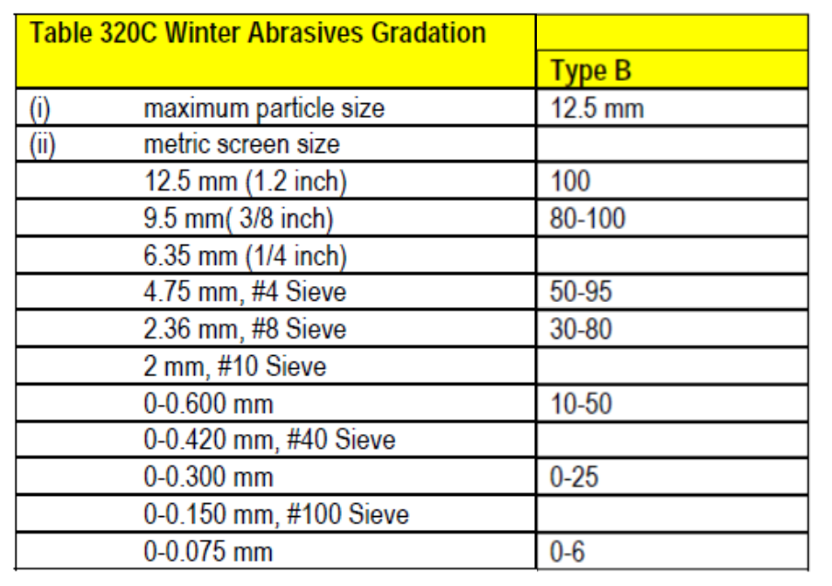
Note: The figures shown in (ii) of the table above represent the percent of material which passes through that screen size.

- The coarse winter salt will be supplied by the contractor and shall conform to the following gradation:
Sieve Size | Percent Passing
9.5mm (3/8 in.) | 100%
4.75mm (No.4) | 20-100%
2.36mm (No.8) | 0-60%
600µm (No.30) | 0-15%
150µm (No.100) | 0-3%

Additional requirements include:

NaCl: minimum 95%
Water-insoluble matter: maximum 1.5%
Material must be reasonably dry and free-flowing.

The quantity of salt needed to make a 4% blend will be approximately 32 cubic yards, a typical load of salt from the supplier will contain approximately 45 cubic yards of salt. For efficiency and to maximise the use of equipment the Owner would like the successful bidder to supply a full load, 45 cubic yards, of salt. The surplus salt will be stockpiled separately at the same site as the blended winter sand, in a location to be determined by the Owner.

- Upon Contract Award, the Contractor shall provide to the Owner a schedule of the work to be completed.

Delivery Requirements

The Contractor will have the material blended and stockpiled at the Owner’s Public Works yard located at 5220 Nicholson Road, Chetwynd, BC by August 31, 2026.

The Contractor shall deposit the product by conveyor belt, to its final location beneath the Owner’s Quonset structure.

The Contractor will supply the conveyor belt, for stockpiling the product.

The Contractor will supply a wheel loader, operators, labourers, and any equipment necessary to blend the product and stockpile the material inside the Owner’s Quonset structure.

RFQ Forms
Bidders should submit only the following documents:
- Form 1 – Company Details
- Form 2 – Bid Sheet

Form 1 – Company Details
By way of submission, we acknowledge that we have received and carefully reviewed all of the RFQ documents, including all posted addenda.

Authorized Signature

Printed Name

Company Legal Name

Date

Full Address

Telephone Number

Email Address

Form 2 – Bid Sheet
In accordance with the RFQ requirements and specifications which I/we have carefully examined, the undersigned hereby submits a firm price to perform the work required for the sum of:

Quantity | Unit | Description | Unit Price (CAD) | Subtotal (CAD)
800 | Cubic Yard | Blending and stockpiling by conveyor, belt of salted coarse winter sand
45 | Cubic Yard | Coarse Winter Salt
Subtotal
GST (5%)
Total (CAD)

Note: In order to comply with the Freedom of Information and Protection of Privacy Act (FOIPPA) and protect the unit prices of bidders, the unit price and calculated subtotals will not be announced or released.

This RFQ will not be opened publicly.

Company Legal Name

